**Data Massage and Fractal Vision in Governance of Danish Education**

*Helene Ratner (hr.mpp@cbs.dk)*

The Danish Ministry of Education is currently changing their Management Information System ‘LIS’. LIS is a database for primary schools, which contains numerical indicators such as test results, continuation in preparatory education, absence from class, well-being, to mention a few. It is mandatory to report on some of these indicators in so-called ‘quality reports’, a municipal management tool for governing primary schools by objectives and results. A central feature of the new LIS is granular access control where municipalities and schools have differentiated access to data, relative to the institutions of which they are responsible. Instead of a monopoly on data access, the Ministry intends to ‘give back’ data to the practitioners who need it to develop a ‘systematic evaluation culture’, as a civil servant phrased it. Speaking of this as a shift of data use from ’controlling’ to ’massaging’ individual primary schools, the Ministry of Education envisions that granular access to data affords a dialectic of information and intervention, in which LIS evaluates and anticipates individuals’ and institutions’ performance.

How to think about this ‘data massage’? Does it materialize a particular ‘ontology of the digital’, as the introduction asks? Following the so-called ontological turn in anthropology, these two questions are deeply related: Put crudely, discussions here emphasize an endeavor to rethink conceptual givens through encounters with alterity in the field (Henare, Holbraad and Wastell 2007) . This implies a relation where the conceptual and empirical forms a perspective on each other: either through conceptual ‘domestication’ of alterity or rethinking own concepts through those of the ‘Other’.

In Science and technology Studies, the stakes are different. Instead of conceptualizing ontology through alterity, debates here emphasize how realities come into being through practical associations of humans and non-humans (Mol 2002) . We can thus not speak of a digital ontology *in general* but rather explore how digital technologies contribute to the making of realities. This also applies to analysis: Rather than posing a question of ‘adequate description’, focus is on how ‘method assemblages’ contribute to the realities they study (Law 2004, Jensen 2013) . Here, I will suggest that LIS can refract questions about performativity so common in educational studies of numbers, revealing how digitally mediated rankings become self-fulfilling prophesies.

‘Data massage’ is not particularly pleasant or relaxing. It is closely intertwined with performance management, a proliferating technology of governance that holds educational institutions accountable on their performance. LIS enacts new notions of knowledge where data is imagined to contribute to qualitative assessments. This problematizes what it means to ‘know’ ones pupils, teachers, and managers. Data is imagined to shape social relationships between teachers-pupils, managers-teachers, and municipalities-schools. New accountability relations materialize as institutions are expected to intervene in the ‘problems’ made explicit by data.

LIS ‘reveals’ problems through particular numerical configurations of difference: as differences between national objectives and status quo, and as differences between parts and wholes. These differences are visualized through column charts, vertical bars showing how data change over time and comparing ‘parts’ to ‘wholes’ (see picture). The vertical axe shows percentage and contains the comparison to national objectives, formulated through a certain percentage of the pupil population. For instance, one national objective is that 80 % of all pupils are ‘good’ at reading and doing math. Here, performance is enacted as either above or below the objective of 80 % and the distance to the 80 % can be closer or further. The red line above each column bar indicates the national average.

The difference between part and whole is more complex. The pupil can be a ‘part’ in relation to the class, the school, the municipality, Denmark. And each of these ‘wholes’ can in turn be viewed as parts: a class can be part of a school, a school of a municipality, the nation. The database can thus both collapse difference and add difference by zooming in and out. We can think of this reproduction of complexity across different levels as fractal, as recursive iterations of patterns within patterns (Mosko 2005:1-46) . Through its fractal vision, LIS at once reifies and obviates relations between parts and whole.

A concluding note on performativity, which here takes the specific form and even has a name: performance management. In STS, performativity is generally used to highlight how theories, models and categories produce reality instead of representing it (MacKenzie 2003:831-868) . This turns around the chronology of reality and representation: instead of reality being prior to representation, representation performs a reality. For the civil servants in the Ministry of Education, however, it is not a choice between representation and performativity. The two are not in contradiction with one another but become entangled in particular ways: They hope that their digital representations will become performative: that they will align how dispersed institutions and practitioners know about and develop their practices.

This hope of performativity is closely entwined with the LIS configuration of difference: the hope is that differences between national objectives and status quo disappear. Once difference has disappeared, objectives have been met. Ironically, this very hope fuels the production of new difference whenever LIS compares status quo to national objective.

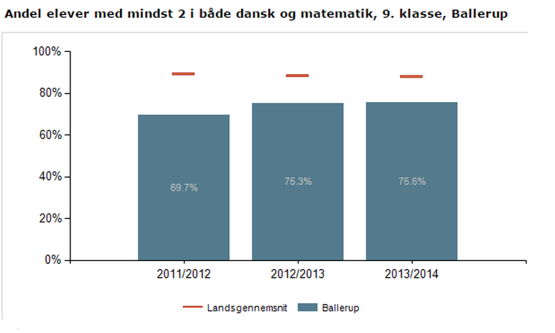

References

Henare, Amiria, Holbraad, Martin and Wastell, Sari. 2007. *Thinking through things: theorising artefacts ethnographically.* Oxon and New York: Routledge.

Jensen, Casper Bruun. 2013. Continuous Variations: The Conceptual and the Empirical in STS. *Science, Technology & Human Values*

Law, John. 2004. *After Method: Mess in Social Science Research.* London and New York: Routledge.

MacKenzie, Donald. 2003. An equation and its world: bricolage, exemplars, disunity, and performativity in Financial Economics. *Social Studies of Science* 33:831-68.

Mol, A. 2002. *The Body Multiple: Ontology in Medical Practice.* Durham: Duke University Press.

Mosko, Mark S. 2005. "Introduction: A (Re)Turn to Chaos: Chaos Theory, the Sciences, and Social Anthropological Theory," *in On the order of chaos: social anthropology & the science of chaos.* Edited by M.S. Mosko and F.H. Damon, 1-46. New York: Berghahn Books.